Potato Cooking Guide

From 11th April 2018 Commission Regulation (EU) 2017/2158 on acrylamide mitigation in food will take effect.
What is Acrylamide?
A chemical formed by a reaction between amino acids and sugars when foods with high starch content such as potatoes, root vegetables and bread are cooked at high temperatures.

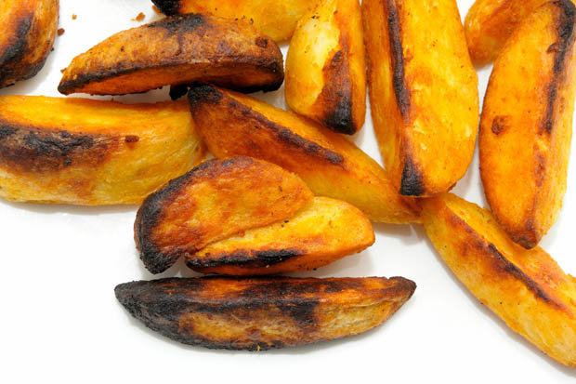
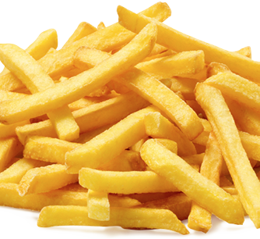
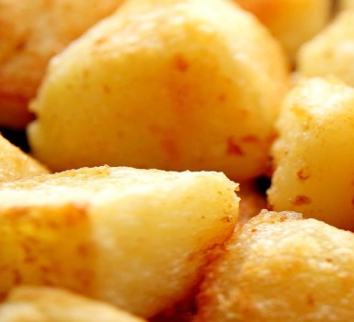
How to lower acrylamide:-
Don’t store raw potatoes in the fridge if cooking at high temperatures.
Soak fresh potatoes for 30-120 minutes in & rinsed before frying.
Blanch if possible

Go for Gold – as a general rule, aim for a golden yellow colour or lighter when frying, baking, toasting or roasting potatoes and root vegetables.

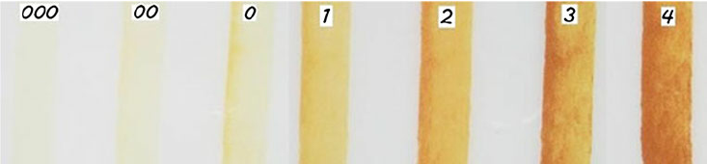
Cook to 2 and that will do……………..

