Bed Management Policy

Policy: C41

Policy Descriptor
The Trust guidance on providing bed spaces for the people who use Trust services who are admitted to hospital to receive care.

If you require this document in a different format or language
please speak to a member of Trust staff.

If you would like to provide feedback about our services
Contact PALS – 01392 675686 or email dpn-tr.pals@nhs.net

Document Control
Policy Ref No & Title: | C41 Bed Management Policy
Version: | v1.6 Retired policy link removed
Replaces / dated: | Previous Policy Dated May 17 Amended June19
Policy Lead: | Corporate Services Manager
Ratifying Committee: | Operations Committee
Director / Sponsor: | Director of Nursing and Professions.
Primary Readers: | All Clinical Wards and Community Teams, Home Treatment Teams HTT), Night Nurse Practitioners (NNP) and On Call Teams
Additional Readers | Clinical / Administrative Staff
Date ratified: | 25th November 2021
Date issued: | December 2021
Date for review / Ratify by: | June 2023 / November 2023
Date archived:

Note: If the above 'Ratify by' date is exceeded then the policy is still valid until it is replaced.
Contents

1. Introduction 3
2. Purpose 3
3. Definition of Terms 4
4. Duties 6
5. Admission to Trust Inpatient units 8
6. Practice standards & principles at interface points between Liaison Psychiatry, HTT, AMHPs and Bed Capacity 10
7. The Processes of Bed Management 15
7.5. Bed Management – Phase One 15
7.6. Bed Management – Phase Two 16
7.7. Bed management – Phase Three 16
7.8. Bed management – Phase Four 17
7.9. Bed Management – Phase Five 18
7.10. Bed Management – Phase Six 18
7.11. Bed Management – Phase Seven 19
8. Devon Partnership Trust Staff Requiring Admission 20
9. On call arrangements 20
10. Mental Health Act s140 (See Appendix I) 20
11. Training 21
12. Monitoring 21
13. References 21
Appendix A – Potential NHS providers 22
Appendix B – Private Provider Notification Form 23
Appendix C – Trust Inpatient Wards 24
Appendix D – HTT requiring Admission to Trust bed 25
Appendix E – HTT requiring Admission to Trust beds Out of Hours On-Call 26
Appendix F – Process relating to clients placed out of area 27
Appendix G – PICU Process & Providers 28
Appendix H – Transport Providers In Order Of Preference 29
Appendix I – Section 140 Admission to Trust wards 30
Appendix J – Inpatient Ward Bed Compliment 32
Appendix K – Bed Capacity Flow Chart 33
Appendix L – Bed Protocol – use of non-designated bed rooms procedure 34
Appendix M – Process For When A Person Is Admitted To Police Custody 35
Appendix N – On Call Director – Requests for Private Beds 36
Appendix O – Child Adolescent Mental Health Service Out of Hours Guidance 37
Appendix P – MBU Admission Pathway 40
Appendix Q – 12 hour trolley breaches Acute Trusts / DPT 42
Appendix R – OMPH HTT External Referrals 45

Introduction

  - An inpatient admission to hospital may be an essential component to a person’s treatment and recovery both to facilitate their care and safety needs and for their families, carers and the public. The Trust recognises that admission to hospital can be a stressful experience for the person, their family and/or carers and with this in mind every effort is made to ensure that the person’s admission is supportive to their needs and is aimed towards their recovery, with privacy and dignity in mind. A person’s Care/Recovery Coordinator (CCO) remains the person responsible for clear communication with the families and carers.

  - There will be occasions when a person is new to services and therefore will not have had a Care/Recovery Coordinator allocated to them who can answer questions about admissions. In these first circumstances i.e. they are detained under the Mental Health Act. The AMHP in the assessing team informs the family and will answer question from families and carers about their admission to hospital. Once a person is admitted to hospital, the ward will be the contact for families and carers until a Care/Recovery Coordinator has been allocated urgently by the community team. If a patient is admitted out of locality without a CCO The Urgent and Emergency Repatriation Coordinators shall act as conduit between the external providers, Community Team and Home Treatment Team to ensure regular contact is made and with a view to repatriating them as soon as practicable back to their local ward and will act as the link for them until a CCO is allocated.

  - Bed Capacity within the Trust is in high demand so the management of resources must be effective and have a consistent approach with clear understanding of the roles and responsibilities by all involved. Home Treatment Team (HTT) are the gate keepers for adult and older adult functional beds.

  - The gate keeping function for adults and older adults with an organic diagnosis is undertaken by the Senior Management for the Older People’s Mental Health [OPMH] Directorate and Belvedere Ward.

  - Access to beds on Additional Support Unit (ASU) (Learning Disabilities), The Junipers (Psychiatric Intensive Support Unit, PICU), Eating Disorder (Haldon Unit), Mother and Baby Unit, MBU (Jasmine Lodge) and Secure Services (Langdon) all have their own referral process (please refer to individual operational procedures for each area access via the hyperlinks)

Purpose

  - This policy has been developed to ensure the optimal use and effective management of the Trust’s inpatient beds so that people receive timely, effective, safe and appropriate inpatient treatment providing guidance to staff of the procedures for arranging inpatient admissions setting out clear direction especially in situations where there is a shortage of available beds within local services. It should be read in conjunction with the Admissions, Transfer and Discharge Policy (C40). Where the requests for beds exceeds that that can be provided due to the lack of beds not only in Devon but nationally this policy should be read in conjunction with the Incident Response Plan.

  - Although admissions are carried out according to the area in which the person lives, there may be occasions when this is not possible or appropriate as a specialist resource such as a psychiatric intensive care unit (PICU) may be required, or when a bed in the local area is not immediately available. The Bed Capacity Team can advise of other beds available in the Trust and how to access these, but considerations must be considered if the patient can be safely maintained in their current environment, or to wait for a bed within their own locality before using beds in other areas.

  - The Trust recognises that in any consideration of bed management priority must be given to persons who are subject to, or are being assessed under the Mental Health Act where no delay is possible, are in a temporary place of safety i.e. POS, A&E, Custody and/or the risks the patient may pose to themselves or others. This includes the outcome of informal admission as a result of a MHAA.

Definition of Terms

  - Approved Mental Health Professional (AMHP) - A Registered practitioner [Social Worker, OT , Psychologist or Nurse] who has undertaken additional recognised professional training and is approved by a Local Social Service Authority (LSSA) to carry out a variety of functions in relation to the Mental Health Act 1983 amended 2007 on behalf of that authority.

  - Central AMHP Team - This is the team that receives all referrals for AMHP involvement during daytime hours in the Trust area.

  - Digital Care Record (DCR) - A clinical electronic care record database in which section details, progress notes, risk assessments and recovery plans are recorded for each person that uses Trust services.

  - Emergency Duty Team (EDT) - This is the team that receives urgent out of hours AMHP referrals in the Trust area.

  - Home Treatment Teams (HTT) - assess people as being appropriate for home treatment and gate keep the admission to the acute ward environment.

  - Hospital Managers - The Organisation (or individual) responsible for the operation of the Mental Health Act in a particular hospital (e.g. an NHS trust, an NHS foundation trust or the owners of an independent hospital). Hospital managers have various functions under the Act, which include the power to discharge a person. In practice, most of the hospital managers’ decisions are taken on their behalf by individuals (or groups of individuals) authorised by the hospital managers to do so. This can include clinical staff. Hospital managers’ decisions about discharge are normally delegated to a “managers’ panel” of 3 or more people.

  - Leave beds - refers specifically to vacant beds where the person is detained under the Mental Health Act (MHA) or is informal, but has been granted a period of leave by their Responsible Clinician

  - Local Delivery Unit - The services, both inpatient and community where the person resides from which the admission is undertaken. (see Appendix C)

  - Mental Health Act 1983 amended 2007 - The Mental Health Act is the legislation governing all aspects of compulsory admission to Hospital, as well as the treatment, welfare and after care of detained persons. It provides for mentally disordered persons who need to be detained in hospital in the interests of their health, their own safety or the safety of other persons. Compulsory admission to hospital is often referred to as ‘sectioning’. The Act sets out when and how a person can be sectioned and ensures that the rights of those detained are protected.

  - Nearest Relative - A person defined by S26 of the MHA who has certain rights and powers under the MHA in respect of a person for whom they are the Nearest Relative

  - Night Nurse Practitioner [NNP] - senior nurse who works at night time as the gate keeper of inpatient beds liaising with the inpatient wards, Liaison Psychiatry and the Emergency Duty Team with respect of admissions to the ward. In localities where there are not 24/7 Liaison Psychiatry teams in situ the NNP would undertake this role.

  - On call Manager - a manager who is available on a Rota system outside of ordinary working hours who can assist with clinical and managerial issues including access to beds.

  - Out of Area Placement - (As defined by the Department of Health) An Out of Area Placement (OAP) for acute mental health inpatient care happens when a person with assessed acute mental health needs who requires adult mental health acute inpatient care, is admitted to a unit that does not form part of the usual local network of services. By this, we mean an inpatient unit that does not usually admit people in the catchment area of the person’s local community mental health service and where the person cannot be visited regularly by their care coordinator to ensure continuity of care and effective discharge planning. Currently In DPT we do have contracted OAP that can be used for admissions with a dedicated DPT staff member to support admissions.

    - Patients should be treated in a location which helps them to retain the contact they want to maintain with family, carers and friends and to feel as familiar as possible with the local environment. OAPs can occur within one NHS provider, in other NHS providers, or independent sector providers (ISPs). DPT have a clear defined process for the monitoring and recording of these and where possible will look to repatriate people back closer to home.

    - NHSE have published guidance on eliminating OAP and suggests key principles to ensure continuity of care. These principles of continuity are:

- Strategic alignment and cooperation across both commissioners and providers within the system – a clear shared vision of the acute system and agreement on what would be deemed an OAP.
- Clear shared pathway protocols between units/organisations – particularly around admission and discharge.
- An expectation that a person’s care coordinator visits as regularly as they would if the person was in their most local unit and retains their critical role in supporting discharge or transition.
- Robust information sharing including the ability to identify cross system capacity and access for clinical records with appropriate information governance inn place where necessary.
- Support for people to retain regular contact with their partners, children, carers and support networks e.g. this might be achieved with optional use of technology, transport provision etc.
- No cross charging (at CCG or provider level) for use of a partner organisations resources e.g. bed use.

    - The Trust has worked with a number of providers to try and meet these criteria. The providers and wards that have met these criteria are Sycamore Ward (Adult Male) and Swift Ward (Older Adult) at Cygnet Taunton Somerset (Cygnet Health Care) and Glenbourne Unit (Adult Male) Plymouth Devon (Livewell Southwest).

  - Place of Safety (POS) - is a designated area for the safety and welfare of persons detained by the Police under Section 135 or 136 of the Mental Health Act. The Place of Safety will be in close proximity to or housed within a Mental Health facility.

  - Repatriation - When there are no beds available within the Trust patients may be placed in external NHS beds or private beds. The Urgent and Emergency Repatriation Coordinators shall act as conduit between the external providers, CCO’s and HTT’s to ensure regular contact is made and with a view to repatriating them as soon as practicable back to their local ward. The bed capacity team will ensure that the local HTT’s are aware of those who require repatriating back to a local Trust bed via weekly locality meetings. The local HTT will liaise with the relevant inpatient ward to determine when a bed will be available. Once this is confirmed the bed capacity team, ward or HTT will contact the external provider to request all nursing documentation is sent and arrange transport to repatriate. If a patient is admitted out of their home locality but within Devon Partnership Trust we should still where possible look to repatriate back to their home locality to support contact with family, community teams and discharge planning, If they have not got an allocated Community worker then Bed Capacity CTL’s will support them till one is allocated and will also ensure that local HTT’s are aware of patients admitted out of there locality that need repatriation.

  - Responsible Clinician (RC) - The RC is the registered medical practitioner in charge of the treatment of a detained person and who is not professionally accountable for that treatment to any other doctor.

  - Safer Staffing & Bed Capacity Team - are the bed flow and capacity team that source out of Locality and Out of Area beds within the Trust, when beds are not available in a person’s local area. When a bed is not available within Devon, the team will source external beds as close to Devon as possible, coordinated with HTT support [i.e. completion of risk assessments, referral paperwork]. The team also have assigned clinicians for each locality that will support out of locality admissions whilst patients are waiting for CCO allocation and support localities in priority repatriation of patients to their home locality.

  - Leave for Informal Patients - this term applies to informal persons who have made arrangements with the clinical team to have time away from the ward leaving their bed vacant. Informal patients are entitled to go on leave from the ward. This is arranged collaboratively with the Inpatient team, RC and family. Although not detained a plan of leave is still completed. It should be noted that leave for informal patients cannot be refused unless a legal framework is invoked.

  - Urgent and Emergency Repatriation Coordinators - Devon Partnership NHS Trust have urgent and emergency repatriation coordinators within the Bed Capacity Team. Their role is to liaise with external providers both for adult acute and PICU beds. They will attend ward review meetings, support implementing discharge pathways and ensure regular clinical updates are obtained to monitor the progress of patients placed out of area. As part of their role they will ensure that the appointed care/recovery coordinators are aware of patients admitted out of area or request allocation of a care coordinator (CCO). They can act as a temporary CCO until a CCO is appointed. HTT’s are also kept up to date re allocation of CCO, and any difficulties with allocation, are escalated to the CMHT team manager and/or Community Services Manager.

Duties

  - Home Treatment Teams (HTT) are the gatekeeping Team for all admissions to functional Adult and OPMH acute admission beds. HTT work closely with the AMHP team and AMHP locality leads and the Emergency Duty Team so that they have an awareness of any Mental Health Act assessments that are planned and where a bed may be urgently required (please refer to Appendix D & Appendix E)

  - There are currently six HTT teams across Devon with direct responsibilities for the following areas:

- Torbay HTT for the Torbay area and align to Haytor Ward, Sycamore Ward and Beech Unit (temporarily Swift Ward at Taunton). In Addition, Stepdown and Crisis beds at Cypress.

- Teignbridge HTT for the Teignbridge area and align to Haytor Ward, Sycamore Ward and Beech Unit (temporarily Swift Ward at Taunton). In Addition, Stepdown and Crisis beds at Cypress.

- South Hams and West Devon HTT for the South Hams and West Devon area and align to beds in the Glenbourne Unit, Haytor Ward, Sycamore and Beech Unit (temporarily Swift Ward at Taunton).

- North Devon HTT for North Devon and align to Moorland View and Meadow View Wards. In Addition, Stepdown and Step Up beds (these are not called Crisis beds) at Wynnstay and St Deny’s.

- Exeter HTT for the Exeter area and align to Delderfield and Rougemont Wards. In Addition Crisis beds at Redhills.

- East and Mid Devon HTT for the East and Mid Devon area and align to Coombehaven and Rougemont Wards, In Addition, Crisis beds at Redhills.

  - The HTT Team Manager / or nominated deputy will attend the daily 9am Trust Wide Call and the MDT meeting on inpatient wards, they will then attend once daily bed conference call at 11:30am, Monday – Friday. They will inform and be aware of the demands for flow and capacity. They will communicate the HTT case load; potential admissions, MHA as well as working with the wards to provide support / consideration to facilitate early discharge, including home treatment. Following the bed conference call they will ensure that the HTT coordinator has the up to date bed information, this includes useable leave beds, non-useable leave beds and the clear written rationale / risk for this decision, if supported by the Inpatient Consultant and any planned MHA assessments by either the Emergency Duty Team or the central AMHP Hubs in Torbay and Devon. Where HTT covers wards which are classed as ‘in area wards’, or step down beds; managed by another provider, the HTT must have up to date information or contact those providers daily, and give patient flow data as part of their conference call update.

  - The AMHP team, AMHP lead and EDT will communicate with the HTT Team Manager, nominated deputy and the Safer Staffing & Bed Capacity Team, and ensure there is awareness of any planned MHA assessments, the likely impact this will have on allocation of beds.

  - The HTT Manager or nominated deputy / bed coordinator will inform the Bed Capacity Manager / team of the requirement for an inpatient bed. Once a bed has been identified through the bed management processes and admissions flow chart (See Appendix D & Appendix E), the admitting clinician with the HTT is then responsible for contacting the identified bed provider and ensuring that all clinical information is conveyed to the receiving team.

  - Local Delivery Units – in conjunction with the HTT, ward or unit, multi-disciplinary community team including the Recovery Care Co-ordinator, should have daily discussions and planning around early discharge facilitation in order to ensure maximum clinically appropriate flow and capacity. This should also include recorded consideration to the potential use of leave beds or beds where people are having time away from the ward.

  - The Older Adult Home [OPMH] Treatment Team is a pilot and provide Professional gatekeeping for older adults within Torbay and Teignbridge, both functional and organic. Functional patients follow the same process as Adult HTTs (gatekeep, put on HTT caseload load, discuss in daily bed call), organic patients are the same but with the additional requirement that we discuss any organic bed requests directly with the OPMH Managing Partner. Referral Process Appendix R

Admission to Trust Inpatient units

  - Admission to the wards are based on age, physical health and the area in which the person lives or for individuals with recent admission history to the ward for that admission, and consideration must be given to the overall clinical risks within the ward environment. The Local HTT are the gatekeepers for admission to these beds, and will be the first point of contact for requests for admissions to beds in their locality.

  - Moorland View, Haytor, Delderfield, Coombehaven, Glenbourne and Sycamore are functional acute adult admission wards. Meadow View, Rougemont and Beech (temporarily at Swift Ward Taunton) provide care to older adults or adults where physical health issue including mobility may make these wards environments more appropriate. The ward environment is different to that of the adult acute unit – for examples differing beds – ligature risk therefore differ and will need to be a factor in determining where a person’s needs are best met is most likely to meet need. Please refer to individual ward Operational policies on Daisy for more guidance.

  - Organic [Dementia] Admission – We are commissioned to support anyone aged 18 or above with a diagnosis of Dementia. An organic inpatient ward is focused on stabilising a person’s mental health and sometimes physical health, allowing them to return home or to access appropriate housing and/or care options.

    - Most organic admissions will be as a result of a Mental Health Act Assessment. Unlike functional admissions, currently the HTT’s do not gate keep the organic beds.

    - Instead the gate keeping function is undertaken by one of the Senior Managers in the Older Persons Mental Health Team [OPMH]. Initial contact should be made with the Senior Inpatient Manager, then either of the Community Service Managers; failing their response you should contact the Managing Partner or Clinical Director. Out of normal working hours referrals to be screened by Belvedere Ward and then discussion with on call manager.

    - Mental Health Act Assessments assessed by the Approved Mental Health Professional (AMHP) cannot be directly accepted to the relevant ward without the input of a Senior Manager from the OPMH directorate.

    - For Out of area Organic admissions, the process is the same for all other admissions other than the responsibility for undertaking the referral when the following should be followed:

- During office hours Monday – Friday 0900-1700 either the OPMH CMHT the patient is allocated to or Admission and Discharge Facilitator on Belvedere. If these are unavailable Bed Capacity CTL will support where possible

- Out of office hours whilst the Bed Capacity Team is working Monday to Friday 1700-2000 and Weekends 08:00 – 20:00- If they have capacity and clinical staff on Duty they will support referral process Out of Hours between 20:00 and 08:00 NNP’s to complete the referral, where they have capacity

  - The Additional Support Unit (ASU) caters for persons with a primary diagnosis of Learning Disabilities. This unit maintains its own bed flow and capacity so referrals for this service gets triaged by ASU. The Blue Light Policy should be consulted to help the local MDT and commissioners identify barriers to supporting the individual to remain at home in the community and to make clear and constructive recommendations as to how these could be overcome by working together and using resources creatively. This should be done prior to any referral for an inpatient bed. Where the outcome of the blue light meeting is a hospital admission this will act as the pre admission CTR. If a person with Learning Disabilities with a primary diagnosis of mental health illness requires a bed then a bed will be sourced by the bed capacity team within an Adult Trust bed, referral to an out of area bed to be avoided. General advice and support will be sought from the Learning Disabilities service to support patient care during their admission to a non-Learning Disabilities ward. A person’s Care/Recovery Coordinator remains the person responsible for clear communication with the families and Carers.

    - For patients with Autism admission to an acute bed should be avoided. Where patients have comorbidity of autism and mental health illness and requires admission [Whereby the need for treatment for mental disorder takes greater priority than needs arising from autism] then a bed will be sourced by the bed capacity team within an Adult Trust bed, referral to an out of area bed to be avoided. General advice and support will be sought from the Learning Disabilities services or Devon Adult Autism Interventions Team (DAAIT), when latter operational, to support patient care during their admission to a non-Learning Disabilities ward. A person’s Care/Recovery Coordinator remains the person responsible for clear communication with the families and Carers.

  - There is an agreed process of escalation to support and authorise HTT staff when a bed is required in terms of identifying the most appropriate place as follows: Where multiple requirements for admission occurs with one bed available, discussions between the admitting Clinician, the Safer Staffing & Bed Capacity Team and the host ward, regarding the most appropriate admission to the bed determined will be based upon the current clinical environment , the risk factors, the presentation and the assessed risks associated with those requiring admission.

  - Protocol regarding who is responsible for finding an acute inpatient bed (“gate keeping”) for an admission (please refer to Appendix D, E & F).

Increasing escalation
Scenario | Bed available within LDU | Bed available outside LDU but within Trust | Bed available outside Trust (including PICU)
In-hours (08.00-17.00) | Local HTT | Bed Capacity Team will locate bed and the HTT will Liaise with receiving Local Delivery Unit / CRHT - delete | Bed Capacity Team will locate bed and HTT or assessing team will refer to that bed
Out-of-hours (17.00-09.00) | Local HTT/NNP | Bed Capacity Team (17:00 – 20:00), Local CRHT - HTT/Night Nurse Practitioner in discussion with receiving HTT/Night Nurse Practitioner | Bed Capacity Team (17:00 – 20:00, Locality Night Nurse Practitioner or On-Call Manager with agreement from On Call Director.

  - “Local” means the Local Delivery Unit (LDU) from where the person is being assessed/admitted from. “Receiving” means the LDU ward or unit where the person is being admitted to.

  - This guidance applies regardless of which part of the service the person is being admitted from (e.g. A&E, GP referral, Community Assessment, Mental Health Act Assessment, POS), and it is for the relevant HTT (as the Trust designated ward and unit gatekeepers) to escalate where necessary via Line Management (On Call Manager/Night Nurse Practitioner out of hours) and identify the most appropriate placement.

Practice standards & principles at interface points between Liaison Psychiatry, HTT, AMHPs and Bed Capacity

Access & First Response (FRS) | Home Treatment Teams (HTT) | Liaison Psychiatry (LP) | Approved Mental Health Professionals (AMHPs) | Bed Capacity
Think MHM 24/7 and The Moorings first.  FRS 24/7 easy access crisis point of contact as an alternative to attending an ED for a mental health crisis (no physical health concerns) undertaking an initial triage using DPT’s Triage Scale.  First Responder Role provides a 4 hour face to face assessment response where capacity allows in all areas excluding North Devon currently. | The role of the HTTs is managed overnight by the Night Nurse Practitioner (NNP) in all localities | The role of LP is covered by the NNP where a 24/7 LP service is not in place | The AMHPs are available via DCC and Torbay’s assigned AMHP service within office hours and via the two Emergency Duty Services (EDS) outside these hours | Bed Capacity are available  08:00 -20:00 Mon – Fri  09:00 – 17:00 W/ends and BH’s  Now 08:00 – 20:00  7 days a week
Patients should not be told they can contact HTT unless the individual is currently accessing HTT input. All new cases that require HTT involvement should be referred in the normal way. Please ensure purpose of involvement is clear – remember goal based care
HTT should not be used for follow up telephone contact for patients unless it is clinically indicated that they require formal HTT input.
A patient’s Nearest Relative (NR) has the right to have a request for MHA assessment considered by an AMHP. Before FRS / HTT and LP colleagues advise an individual’s Nearest Relative (NR) of that right, particularly when they themselves are declining a service, they should first contact the AMHP service themselves to establish the appropriateness of such a referral, what lawful alternatives might exist, and advise the NR accordingly.
Step up in Care: Home-treatment
Access & First Response (FRS) | Home Treatment Teams (HTT) | Liaison Psychiatry (LP) | Approved Mental Health Professionals (AMHPs) | Bed Capacity
The FRS after a clinical triage will establish the outcome required in accordance with DPT’s Triage scale (A – G).  Where a face to face review / assessment is clinically indicated people meeting code B (4 hour response) and above, the person will be reviewed / assessed by either the FRS or the HTT where capacity allows. ..  If a person is open to a DPT CMHT and clinical records are in date, a full bio psychosocial assessment is not required. An SBAR within clinical records is sufficient.  If the FRS have undertaken the review / assessment and home treatment is indicated the FRS will contact the relevant HTT or NNP; handing over the case.  There may be occasions whereby a joint review / assessment is indicated with the FRS and HTT. | Where home-treatment is indicated, HTT will agree with the individual direct or via the referrer when the first contact will occur.  (HTT accept the referral ensuring that the person has their needs met, where there are reflections that an alternative plan may have been more appropriate then this should be discussed between team managers) | When LP identify that a person requires an intensive level of support (Home Treatment/ Admission) they refer to the relevant HTT to discuss the person’s needs. The HTT will reach a decision about the level of intervention based verbal handover and clinical record.  In circumstances where a consensus can’t be achieved; the HTT may wish to complete a face to face review to establish if presenting needs can be appropriately supported by Home Treatment Intervention.  LP will update DGH of outcome / plan | AMHP service will ensure local HTT aware of request for MHA assessment to discuss potential home treatment capacity to support the individual (where HTT are not the referrer).  Before an offer of home treatment is made to the patient during the MHA assessment process, the AMHP must first establish with HTT that they are able to facilitate the proposed plan. | Bed capacity do not have a role at this point

Access to Psychiatric Acute Care and the Gatekeeping Role / Mental Health Act Assessment (MHAA)
Access & First Response (FRS) | Home Treatment Teams (HTT) | Liaison Psychiatry (LP) | Approved Mental Health Professionals (AMHPs) | Bed Capacity
When FRS* considers that a person requires a Mental Health Act Assessment; the care needs should be considered with HTT in the first instance.  Principles outlined in SOPS regarding Capacity & Consent should be considered and decisions recorded in the care record.  *Where contact has been via tele-coaching and not face: face assessment; FRS / HTT should consider options and include AMHP colleagues were applicable | HTT are the ‘gatekeepers’ to psychiatric acute care, this includes home treatment and admission  Principles outlined in SOPS regarding Capacity & Consent should be considered and decisions recorded in the care record.  Consideration of the suitability & capacity for HTT to be part of the MHAA or how outcomes of the assessment will be shared / consider jointly. | When LP considers that a person requires a Mental Health Act Assessment; the care needs should be considered with HTT in the first instance.  Principles outlined in SOPS regarding Capacity & Consent should be considered and decisions recorded in the care record. | In considering request for a MHA assessment, when concluding that one should proceed the AMHP must discuss the case with the HTT shift co-ordinator to consider what role the HTT might have in reducing the need for admission.  Consideration of the suitability & capacity for HTT to be part of the MHAA or how outcomes of the assessment will be shared / considered jointly. | Bed capacity will locate a bed only if there is no local bed available.  They are not gatekeepers to the beds.  n.b. during Covid incident bed capacity should be approached re every admission
Where the discussion between FRS and HTT results in a view that MHAA is the most appropriate way to proceed; FRS will contact the AMHP service to consider clinical information and request the MHAA. | Following an AMHP’s consideration of the case, HTT will be contacted to establish their potential involvement or role in bed finding. | Where the discussion between LP and HTT results in a view that MHAA is the most appropriate way to proceed; LP will contact the AMHP service to consider clinical information and request the MHAA. | AMHPs will inform HTT when a MHA assessment is considered appropriate in order to consider home treatment options and to ensure their involvement for bed finding purposes. | Bed Capacity should be kept updated for potential admissions by HTT.  They have overall knowledge of who is awaiting admission within DPT and this is shared within the daily conference calls and on-call bed state report.
Inpatient Care
Access & First Response (FRS) | Home Treatment Teams (CRHTT) | Liaison Psychiatry (LP) | Approved Mental Health Professionals (AMHPs) | Bed Capacity
Where admission to a psychiatric bed is agreed then HTT will manage the patient in the situation that a bed cannot be identified, handover of care will be agreed by discussion. | If inpatient care is indicated, HTT will ensure by discussion with LP / FRS that capacity to consent to voluntary admission has been assessed and documented.  Where this is the outcome of an MHA assessment, the first assessing doctor should record this in Care Notes. | At the point that a decision to admit to a psychiatric bed has been made LP remain responsible for reviewing the clinical care of the person and supporting the DGH staff until they are discharged from the DGH. | If the admission awaited is a formal admission under the MHA, doctors making the recommendations & the AMHP will ensure an interim management plan is in place and documented. This may require input from HTT if the situation allows. | Bed Capacity should be alerted at the earliest opportunity by the assessing team re the potential need for a bed.

Bed Locating and Communication
Access & First Response (FRS) | Home Treatment Teams (HTT) | Liaison Psychiatry (LP) | Approved Mental Health Professionals (AMHPs) | Bed Capacity
For a community based patient, an agreement should be reached as to who will remain the point of contact for the person / family whilst bed finding commences. | For a community based patient, an agreement should be reached as to who will remain the point of contact for the person / family whilst bed finding commences.  HTT should commence bed locating by looking at local stock and if not available, handing over to Bed Capacity to source an alternative, as per agreed protocol  HTT will agree with Bed Capacity which team will maintain contact with LP/AMHP/FRS.  The agreed team will ensure clear communication is maintained and updates are documented on the electronic record case notes. | LP will be the primary point of contact for the DGH and the patient, whilst the patient remains in the DGH.  The relevant team will update LP once a bed has been located  LP liaise with agreed team (HTT/Bed capacity) to receive timely updates on progress and update the DGH as per the 12 hour breach SOP – a record will be kept on the 12 Hr Breach Reporting Form. | If requiring detention under MHA, the AMHP can only make the formal application once a bed is located.  The relevant team will update AMHP once a bed has been located. | Bed capacity will contact HTTs to determine local bed availability on a daily basis. Bed capacity will inform HTT’s of where bed availability is within DPT.  If there are no DPT beds, Bed Capacity will take over the search for an out of area bed. Once the bed is identified Bed Capacity will inform the HTT/LP/FRS.  The assessing clinical team will make the clinical referral.  HTT will agree with Bed Capacity which team will maintain contact with LP/AMHP/FRS.  The agreed team will ensure clear communication is maintained and updates are documented on Care Notes
HTT patient attends Emergency Department
Access & First Response (FRS) | Home Treatment Teams (HTT) | Liaison Psychiatry (LP) | Approved Mental Health Professionals (AMHPs) | Bed Capacity
No role in the situation | Actively engaged with HTT; Review by HTT if possible or LP if HTT cannot meet timely review and discharge from the DGH is delayed  Joint reviews should be considered | If actively engaged with HTT; review by HTT where possible; where timescale for timely review cannot be met by HTT; LP will assess  Joint assessment should be considered | No role for AMHPs, but available for advice. | No role for Bed Capacity
Non-Devon Presentations to the DGH / AMHPs
Access & First Response (FRS) | Home Treatment Teams (HTT) | Liaison Psychiatry (LP) | Approved Mental Health Professionals (AMHPs) | Bed Capacity
No role in the situation | No role in the situation | When LP assess an individual with a GP outside of the DPT locality, the team should address their discussion about onward acute care with the person’s local team.  If an admission is indicated, LP will inform Bed Capacity who will undertake the bed search in relevant locality. | If detention under the MHA is required AMHP will liaise with Bed Capacity who will undertake the bed search on the relevant locality. | Bed Capacity will liaise with the out of area bed capacity teams to request they identify a bed
Clinical handovers to the expecting ward will be undertaken by the assessing clinician / team

  - The decision to use the beds of persons that are on leave or having time way from the ward rests with the relevant local HTT and Inpatient Ward Manager/Senior Nurse Manager in the first instance or nurse in charge in conjunction with the Bed Capacity & Safer Staffing Manager. Out of hours this decision will be made with Nurse in charge, NNP and on call Manager Manager/Director. If the person is detained under the MHA only the Responsible Clinician can grant leave or make changes to the conditions attached to any period of leave (MHA Code of Practice 21.6).The Trust supports and encourages the use of the beds of persons that are having time away from the ward or are on leave (especially if the person is relatively stable, and can continue to be supported by the HTT and community teams), in the spirit of positive therapeutic risk taking and recognises that this will reduce the clinical risk inherent in sending persons out of Devon, especially out-of-hours. If a bed is to be left unused, there must be robust clinical rationale to do so, which is identified as such in advance of the leave being taken and clearly recorded within the Digital Care Record progress notes – detailing the rationale and risk.

  - Where staff members need to discuss individual persons in relation to admission with colleagues, they should only access clinical information necessary for this purpose. It is not appropriate to check the clinical data relating to other persons in the ward or unit as this knowledge is held locally and to do so may contravene Data Protection legislation.

  - Admission to Older Persons Units

    - The Trust is aware of the overall pressure within both inpatient services and community. It is essential that staff work together on the basis of trust, mutual respect and transparency providing the best possible care response for all.

    - The OPMH inpatient wards (Beech (Swift Temporarily), Meadowview and Rougemont) accept people with a functional mental illness who are usually 65 years and over. Younger adults can be considered for admission to these wards following a clinical discussion and agreement with ward consultant, ward manager and Inpatient Senior Nurse Manager during the working week or with agreement with the on call senior manager and on call director.

    - All Dementia admissions must be agreed by a senior clinician (consultant psychiatrist/community team manager/ advanced practitioner) involved in the individuals care and OPMH managing partner or delegated party in hours or on call senior manager out of hours. These individuals will be responsible for ensuring appropriate measures are taken to ensure quality of care and patient safety.

    - There are occasions where admission to a functional ward may be identified as best meeting the needs of the individual who has a dementia diagnosis (e.g. a patient with early dementia who is suicidal or displays predominantly depressive symptoms may be better placed on a functional ward; in this instance this admission would be considered a functional admission).

Any Patients felt to require hospital treatment for a functional mental illness should not be admitted to Belvedere ward.

    - There are times where Belvedere Ward does not have sufficient capacity for those who require a dementia bed. In this instance, wherever possible an admission should be delayed until a bed is available or alternatives sought.

The use of an out of area OPMH bed both Functional and Organic should be a never event and only considered where there is a clear clinical rational and an immediate risk to the patient or others.

  - An out of area OPMH bed should only be used if there is a clinical, significant and immediate risk to the patient or others. The quality of patients care is largely outside of the Trusts control in out of area beds and should be avoided at all costs. Decision to admit to an OOA bed must be authorised by OPMH Director and clear clinical rationale documented for this decision and a clear follow up process in place to monitor the patient.

    - When considering the use of an OPMH functional bed for an Organic Patient, the following process should be followed:

- Discussion should be had with the Nurse in Charge on Belvedere Ward and the Nurse in Charge of the Functional Ward where the bed exists to consider whether the transfer of an existing patient from Belvedere to the Functional ward is preferable, in order to facilitate the admission to Belvedere. The safety of staff and patients as well as all other relevant factors should instruct this decision.

- Where an individual with a diagnosis of dementia is admitted to a functional ward this needs to be done in consultation with the ward manager, OPMH Senior Management and ward responsible clinician wherever possible. It is required that ward staff will draw up suitable care plans which ensure the safety of the patient with dementia and the other patients on the ward. If additional staffing is required then this should be requested and escalated as necessary. Once agreement is reached that the admission can go ahead. Bed capacity team and AMHP and AMPH service should be notified.

- If more than one dementia patient requires admission to a functional ward then patients should be distributed across all OPMH functional wards based on risk and area of county admitted from. Due to the differing and often high needs of individuals with an organic diagnosis; it is recommended that each functional ward should not admit more than two people for dementia related needs, however, this should be considered on a case by case basis.

- Any organic admission to a functional ward is against our usual practice and should be incident reported using the RMS system, stating admission to inappropriate ward.

- Consideration should be given to moving the individual to Belvedere Ward at the earliest opportunity where it is felt that clinical needs are best met by a dementia care ward.

  - Children and Young People - The Trust is responsible for delivering the emotional health and wellbeing element of a contract within the Alliance of other local Health and Social Care providers of what was previously known as the Child and Adolescent Mental Health Service [CAMHS], previously managed by Virgin Health Care. The other partners are the Royal Devon and Exeter NHS Foundation Trust, Northern Devon Healthcare NHS Trust, University Hospitals Plymouth and Livewell Southwest. Although there are many providers, the ethos will be to create an integrated and seamless service offer for children, young people and their families. The Trust is not currently responsible for bed provision, but has a duty as part of the local STP to support in an emergency. Guidance in Appendix O

  - Mother and Baby Unit [MBU] - The Trust now hosts the Regional MBU. The MBU has its own processes for admission. Please refer to Appendix P for guidance.

  - Haldon Unit [Eating Disorders] - The Trust now hosts the Regional Service. The Haldon Unit has its own processes for admission. Click here

  - Twelve [12] Hour Breeches - Please refer to guidance in Appendix Q

  - Person in Police Custody requiring admission - Please refer to Appendix M

The Processes of Bed Management

  - When considering a need to admit a person to a ward or unit the following process should always be adhered to:

- Phase One: Admit person to a local bed within pre-defined geographical boundaries.

- Phase Two: When the ward responsible for admissions has no vacant beds, then discussion regarding usage of “leave” beds should occur.

- Phase Three: Transfer of a person to another ward to create a bed space, the facilitation of early discharge or consideration of alternative options to Inpatient admission.

- Phase Four: All beds across the Wards or units are occupied: and a bed must be sought outside of the LDU, but within the Trust.

- Phase Five: All beds in the Trust are occupied. Seek alternative NHS bed for short term placement – Please refer to Appendix A

- Phase Six: If no NHS beds available consideration needs to be given to using an approved private hospital provider out of county (requires Director Approval). Please refer to Table 1 on page 17.

- Phase Seven: When beds are not available within the NHS or Private and/or person cannot be admitted into an external bed due lack of transport or time of day. Then the Bed Flow protocol is to be initiated – Please refer to Appendix J & Appendix K.

  - Delays in identifying an appropriate bed that lead to a level of clinical risk or poor person experience must be incident reported. An incident report should also be completed if there are delays in organising the appropriate transport. See R01 Incident Reporting Policy

  - It is likely that the escalation process as previously described will apply in agreeing some of the phased options and staff may need to liaise with senior staff to assist with some decisions.

  - At all times during the bed management process, the needs of the patient have to be taken into consideration. The Trust will make no discriminatory decisions based upon any factor pertaining to the individual’s person, their right to practice religion, their age, ethnicity, gender and other contributing factors to a person’s wellbeing. Patient privacy and dignity will be maintained at all times during the bed management process. Where individual cases of bed management procurement may have extenuating circumstances regarding gender transition, due consideration will be given to the patient’s wishes and guidance may be sought from professionals within the Laurels Gender Identity Service 01392 677 077 dpn-tr.TheLaurels@nhs.net were applicable.

Bed Management – Phase One

    - Admission should be directed towards available bed within Local Delivery Unit dependent upon risk assessment and deemed suitable for the reserved bed. These are Gate kept by the Local HTT for each area.

Bed Management – Phase Two

    - The ward or unit taking admissions from within its LDU has no beds, then usage of leave beds should be considered.

    - In the case of there being no beds available on the designated ward, then the Ward Manager or Senior Nurse Manager must consider and discuss with MDT – and inform the Bed Capacity Team the use of leave beds or the beds of people who are having time away from the ward.

    - In the case of leave beds or the beds of people who are having time way from the ward being used then the following actions must be considered.

    - After considering the existing clinical issues and pressures on the ward or unit, and the likely needs of the person being admitted, the HTT and the Ward Manager or Senior Nurse may decide that the usual ward or unit for that area is not suitable to accept the admission. When this is indicated the admission will be diverted to the Bed Capacity Manager / team to identify an alternative appropriate ward.

    - Extending existing leave periods/time way from the ward, where this is appropriate – ensure that the appropriate HTT and/or recovery coordinator, carers and the person’s usual community resources are aware of the extension and are in a position to offer increased support and monitoring over the extended leave period or for the person’s extended time away from the ward.

    - Bringing forward planned leave/ time way from the ward where this is appropriate – ensure that the appropriate HTT and or recovery coordinators, carers and the person’s usual community supports are aware of this and if needed are in a position to offer increased support and monitoring.

    - Early discharge might be considered where appropriate. In the case of persons that are subject to a section 3 or have S117 aftercare entitlement from previous admission under the MHA then a S117 aftercare meeting should be arranged. If this happens then an urgent discharge planning meeting or telephone conference call must be arranged, which would include:

- HTT Team Member
- Responsible Clinician
- Family/Carers
- Recovery coordinator or deputy
- Ward doctor/Consultant

Bed management – Phase Three

    - Transfer of a person to another ward or unit within an LDU to create a vacancy. Where this is undertaken care notes forms should be update as per guidance https://daisy.dpt.nhs.uk/directorates/corporate/finance-imt-estates-and-informatics/dpt-it-services/clinical-systems-it-training/carenotes-user-guides.aspx

    - The utilisation of on-leave beds/or beds where people are having time away from the ward should be considered and actioned before a person’s transfer is considered.

    - If a person is detained under a Section of the MHA then the responsible clinician should be consulted where ever possible about the transfer of the person to another ward.

    - The ward manager/senior nurse from the transferring ward or unit will determine if there is a person suitable for transfer. People will not normally be expected to transfer from one place to another after 8pm in order to minimize disruption. This option should be explored within normal working hours and a named person identified, this must be in line with the C40 Admission, Discharge & Transfer Policy

    - Discussion and explanation must occur between the person involved and the senior nurse on duty from the transferring ward or unit.

    - The ward manager/nurse in charge will ensure all relevant information is handed over to the receiving ward or unit, including all identified risk factors. If the person has been detained under the mental health Act then Section 132 rights are read to them by a qualified nurse. It is the responsibility of the transferring ward or unit to inform all relevant person(s) of the transfer i.e. nearest relative, carers, recovery co-ordinator.

    - The person should be escorted to the receiving ward or unit and they should be introduced to that ward or unit staff. All relevant documentation and person’s property should be taken with them to the receiving ward or unit.

    - There may be exceptions to the above that may need individual consideration and a decision will be made by Ward Managers/Senior Nurse Managers.

    - It may be necessary at times to ensure safe and effective delivery of care that a decision is made by ward manager/senior nurse manager/responsible clinicians to divert an admission even though there are vacancies on the ward or unit in that area. This would occur at exceptional times when the ward or unit are working to particularly high risk pressures and the persons’ needs cannot be met.

Bed management – Phase Four

    - When all other options have been exhausted and a bed must be sought outside of the LDU. See:
- Appendix C
- Appendix D
- Appendix J

    - In Hours the Safer Staffing & Bed Capacity Manager/Team will establish the availability of beds in other LDU areas and negotiate the use of a bed if one is available, this will be via the once daily bed conference calls. It is important that the HTT have a clear understanding of the bed availability within their own LDU. The AMHP HUB, AMHP leads and the Emergency Duty Team should ensure the HTT Teams and the Safer Staffing & Bed Capacity Team are informed about Mental Health Act assessment that are under way where a bed may be required.

    - A summary of the clinical information, Mental Health Act status and risk status of the person for whom the bed is being sought, should be given to the appropriate HTT /Ward by the admitting clinician seeking the bed. This information also needs to be available on the person’s Digital Care Record. There also needs to be a follow up call confirming transfer arrangements.

    - The admitting clinician must ensure that the person and their families are aware of the bed situation, with the possibility of admission out of their respective locality.

    - Out of hours (see Appendix E) – The HTT or NNP will take responsibility for identifying available beds and coordinating the transfer of the person.

    - If a bed is accessed out of local LDU the Safe Staffing & Bed Capacity manager must be informed who will ensure arrangements are made for the timely repatriation of the “person” as soon as possible. Repatriation must be prioritised at the earliest possible opportunity, within working hours, in recognition that there are major issues for people and their families when a person is placed out of area. Repatriation is based upon the risk assessment and on the needs led basis.

    - Once a potential bed has been identified it will be the responsibility of the assessing clinician to complete the pre-admission risk assessment – along with any other clinical information requested – completion of ECR admission form – Appendix B

Bed Management – Phase Five

    - All beds in Devon are occupied – All other NHS providers must be explored for bed availability (See Appendix A).

Bed Management – Phase Six

    - In the absence of any NHS beds locally and having explored carefully and ruled out all options in Phase 1, 2, 3,4 & 5 consideration should be given to accessing a bed in a private hospital that is suitable in meeting the person’s needs. Before this is considered the HTT Manager or nominated deputy must liaise with the appropriate Locality Manager to review that OOA bed is required and then escalate to Managing Partner/deputy or Corporate Services Manager at Safer Staffing & Bed Capacity Team to seek authorisation. Out of hours the NNP will contact On Call Manager who in turn will seek On Call Director authorisation to place a person outside the Trust. All senior clinical and managerial on call persons including consultants must be involved in the response / decision making to these requests. An RMS must be completed, a private notification form and the on call manager request for private bed checklist. These must be sent to the Safer Staffing & Bed Capacity Manager (dpn-tr.bedcapacity@nhs.net) – in and out of hours.

    - The Safer Staffing & Bed Capacity team will circulate an On Call Managers/Consultants Bed State Report every evening Monday to Friday and in the afternoon at weekends. The information will contain the current bed availability, any outstanding bed requests (including the current actions in place) and the contact numbers for all relevant team. There is also a Bed Capacity page on daisy https://daisy.dpt.nhs.uk/quality-safety/bed-capacity-and-safe-staffing.aspx

    - External/Private bed availability will be located by Safer Staffing and Bed Capacity Monday to Friday between 08:00 to 20:00 and Weekends 08:00 to 20:00. Outside of these hours Local HTT’s and NNP will coordinate. OOA bed availability details will be passed onto the relevant teams or persons to start referral process

    - Once a potential bed has been identified it will be the responsibility of the assessing clinician to contact the provider, offer a clinical description of presentation and needs including a risk assessment and to follow this up with appropriate documentation and to organise the appropriate transportation (see Appendix H). Maintain communication with the family/carers and with the Care co-ordinator to ensure effective flow of relevant information. Complete private notification form Appendix B. Where there has been no involvement by the HTT in the assessment of a patient who requires OOA bed from their Locality, they still remain responsible as Gatekeepers for ensuring a referral is completed

    - The Safer Staffing & Bed Capacity team must be informed if a bed is found and utilised within any other LDU, NHS or Private area. Repatriation must be prioritised at the earliest possible opportunity, within working hours, in recognition that there are major issues for people and their families when a person is placed out of area. Repatriation is based upon the risk assessment and on the needs led basis.
Table 1.Private Hospitals
Cygnet Hospitals – Acute – 0808 164 4450 For referrals use Cygnet referral Line between 08:00 and 20:00 outside of these hours you will need to contact Cygnet wards individually availability of beds is available on line– Cygnet have a referral form and require copies of Risk Assessment, Progress Notes, Care Plans, Assessments, Medical Charts and MHAA paperwork. Details for all Cygnet Hospitals can be found On Cygnet Website
Priory Hospitals – Acute/PICU - Priory Hospitals – Central Referral Line (24 Hours) – 08450 005 050 – Priory will take telephone referral in first instance and direct referral to most appropriate priory bed, then will need copies of Risk Assessment, Progress Notes, Care Plans, Assessments, Medical Charts and MHAA paperwork. Details for all Priory Hospitals can be found On Priory Website
Elysium Healthcare – Acute/PICU – Referral Line 24 hours - 0800 218 2398 – Elysium have a referral form and require copies of Risk Assessment, Progress Notes, Care Plans, Assessments, Medical Charts and MHAA paperwork. Details for all Elysium Hospitals can be found On Elysium Website
St Andrews Healthcare – PICU – Referral Line – 01604 616000 – Direct telephone Referral to individual ward then referral form and require copies of Risk Assessment, Progress Notes, Care Plans, Assessments, Medical Charts and MHAA paperwork. Details for all St Andrews Hospitals can be found On St Andrews Website
The Huntercombe Group - PICU – Direct Number 0330 660 5555 – Direct Telephone call then referral form and require copies of Risk Assessment, Progress Notes, Care Plans, Assessments, Medical Charts and MHAA paperwork
Correct at date of policy

Bed Management – Phase Seven

    - Where there are no national beds available within hours then the Safer Staffing & Bed Capacity team will escalate the national bed situation to the respective Director. Out of hours the on call Manager must inform the on call Director, who will then contact the Clinical Commissioning Group or NHS England to seek further advice.

    - Where no national beds are available, and consideration is being given to creating a temporary best interest solution within the Trust, consideration must be given to acute admission services as the first option and what would need to be put in place to make this safe. Non acute admission services such as Russell Clinic, the Haldon Unit must be an absolute last resort and consideration should be given to safe transfers through the use of section 17 leave of people who are most appropriate for the environment for the minimal period needed, rather than direct admissions.

    - When Trust beds are not available either due to there being no vacancies or leave beds to admit to the following process has to be followed. Admission or holding within 140 to Place of Safety (POS) would be considered in an emergency with agreement from the Senior Nurse Manager in hours or via Director on call (See Appendix I). This may include an extra provision of staff to allow safe nursing of the person accessing the service away from the ward environment. Please refer to
- Appendix C
- Appendix J
- Appendix K
- Appendix L

    - Non designated Bedroom’s i.e. female lounges should not be considered as temporary bedrooms (see Appendix J and Appendix L)

Devon Partnership Trust Staff Requiring Admission

  - In the event of a Trust staff member requiring an admission, sensitivity to their needs will be paramount, whilst maintaining their privacy and dignity, During normal hours this delicate situation will be administered by the Safer Staffing & Bed capacity Team 01392 208 698. Out of hours escalation will go through the NNP and On Call Manager.

- On call arrangements

  - The Trust has on call arrangements when it is necessary to gain assistance with clinical and managerial issues. There is an on call Manager and on call Director available from 5pm until 9am each week day and from 9am until 9am each bank holiday and weekend. There is a Consultant psychiatrist and junior doctor also on call. There is now one central on call rota that is on Daisy and also kept by the hospital switchboard operators in Exeter RD&E. This rota includes Exeter, East & Mid, North Devon and South Devon. On call managers are expected to attend the 16:00 bed conference call on a Friday to obtain the most accurate and up to date bed data, as well as any potential staffing issues. In Addition they are required to attend 9am trust wide call Monday to Friday this will allow them to update any issues raised overnight and to get an overview of system wide issues to support there on call.

  - Following on from this 16:00 conference call, the weekend on call rota, and all bed details will be circulated to the whole on call team for that weekend; there will also be a discussion between on call whether a 10am conference call is required Saturday and Sunday, and the times they will occur. The 10am Conference call will be attended by On call Director and Senior Manager, Secure Services On Call Manager and the Bed Capacity Team

  - The Trust Forensic service based at Langdon Hospital has an alternative on call arrangement. The Langdon Hospital Reception number is 01626 888372 (Monday to Friday 8:30 to 16:30), outside of these hours Dewnans Control Base act as main reception on 01626 884520. Forensic Services participate within the 16:00 conference call on a Friday and within the conference calls at 10 am on Saturday & Sunday. Details will also be posted on Daisy with other on call information.

- Mental Health Act s140 (See Appendix I)

  - Section 140 of the Mental Health Act 1983 places a duty on Clinical Commissioning Groups to notify the Local Social Services Authority of the arrangements in place for the reception of patients in cases of special urgency, where there is no bed available to detain a person to in urgent situations.

  - The Mental Act Commission suggested that if a person cannot be admitted to hospital in an emergency for want of a bed, the AMHP should complete an application, making it out to the hospital which has been the subject of notification under this provision, and convey the person to hospital. (Jones 1-1281)

  - The effect of s140 and the advice of the Commission is an expectation that the AMHP’s may make an application and convey a person to the named hospital, regardless of the actual availability of a bed although in the first instance the AMHP must give notification of the intention and discuss with the HTT. The Trust might be asked to accept a detained person where there is no bed available with a view to addressing this need once the person is in the hospital. S140 only applies to urgent clinical risk situations, where an excessive wait for an identified bed has been assessed to increase the risks to the person or AMHP to an unacceptable or unmanageable degree in the community situation. Decisions made to use this part of the act should be made in conjunction with the AMHP, Senior Nurse Managers or On Call Manager and Service Manager for the LDU area, this will be extreme exceptional circumstances;, Senior Nurse Managers between the hours of 9-5, Mon-Fri. Out of Hours the NNP or On Call Manager who will escalate to the On Call Director if required, so that the most appropriate hospital can be identified and agreed and assistance with risk management decisions can be given. The nature of s140 means the timeframe of implementing arrangements must be kept to a minimum and unnecessary

  - Delays avoided. Responsibility for the subsequent identification of an appropriate bed for the person will be retained by the HTT for the LDU area that the person has been admitted to. Staffing must be considered as well current clinical risk if a Section 140 is to be initiated.

  - Incident forms should be submitted by Ward Managers or NNP out of hours when S140 is invoked. See R01 Incident Reporting

Training

  - All On Call Managers will receive face to face training on the Bed Management procedures.

  - Clinical Team Leaders of Home Treatment Teams will deliver face to face training to their team members on Bed Management, as well as on-going support and development through individual supervision.

Monitoring

  - Team dash boards will monitor gatekeeper / bed capacity statistic (see Adult Clinical Directorate Protocol) and these are reviewed at Adult directorate governance meetings.

  - An Audit will be conducted annually to review bed capacity & incidents of exception which will include consideration of delayed transfers of care, out of area placements, and complaints received by PALs.

  - Review of all RMS incident form should be carried out at local level to ensure overall governance of the process.

References

MHA Code of Practice
Jones Robert, Mental Health Act Manual
Fifteenth Edition

Appendix A – Potential NHS providers

Area | Name | Contact Details
Cornwall | Fletcher Ward | 01208 251377
 | Longreach House, Camborne | 01209 881900
 | Crisis Team
 | West County | 0845 2303902
 | East County | 0845 2303901
Somerset | Rydon House | 01823 333438
 | Rowan Ward | 01935 410784
 | St Andrews Ward, | 01749 836627
North Somerset | Juniper Ward, Long Fox Unit, West General Hospital | 01934 836 484 / 5
Plymouth | Bed Manager | 01752 434604 or 434607
 | Glenbourne Unit, Reception | 01752 763103
 | Out-of-Hours | 01752 669709
 | Crisis Team | 01752 314033
Bristol | Bed Co-ordinator | 0117 919 2336/01225 325680
 | Blackberry Hill Hospital, Bristol - Wickham Unit | 0117 378 4300
 | Callington Road Hospital, Bristol - Lime | 0117 919 5933
 | Callington Road Hospital, Bristol - Silver Birch Unit | 0117 919 5901
 | Fountain Way, Salisbury - Beechlydene Ward | 01722 820150/156
 | Green Lane Hospital, Devizes - Imber Ward | 01380 731200 x 202
 | Hillview Lodge, Bath - Sycamore | 01225 362735
 | Long Fox Unit, W-s-Mare - Juniper Ward | 01934 836484
 | Sandalwood Court, Swindon - Applewood Ward | 01793 836841
 | Southmead Hospital, Bristol – Oakwood Ward | 0117 414 6632/6631

Correct as of January 2021

Appendix B – Private Provider Notification Form
Private Provider Notification Form

All requests for private beds MUST be agreed with the bed manager or nominate deputy in their absence before any approval

MUST BE COMPLETED BY REFERRER FOR ALL CLIENTS ADMITTED TO PRIVATE AND / OR WHEN ADDITIONAL SUPPORT IS AGREED |  |  | NHS Number
Person’s Name |  | Person’s Address
Date of Birth | Carenotes No. | GP Name, address & telephone number
Care Coordinator * |  | Consultant
Diagnosis in full |  | Legal Status (MHA status, Section 117, Court of Protection)
Admitted to : Hospital Name |  | Ward Name
Date and time of Admission |  | Transported by (Company)
Reason for Admission

Where was the person admitted from:- Home*, Community*, Police Custody* Other

Network Area |  | Senior Nurse Manager

* If there is no identified Care Coordinator, the Client must be allocated one as a priority

Send electronically to:

The Bed Capacity Team dpn.bedcapacity@nhs.net and Senior Nurse Manager for your Area

Appendix C – Trust Inpatient Wards

Area | Name | Contact Details
Exeter & East | Belvedere Ward – Older Persons (Organic) | 01392 674310
 | Belvedere Ward - Manager | 01392 674313
 | Coombehaven Ward | 01392 674907
 | Coombehaven Ward - Manager | 01392 674908
 | Delderfield Ward | 01392 674912
 | Delderfield Ward - Manager | 01392 674911
 | Rougemont Ward – Older Persons (Functional) | 01392 674300
 | Rougemont Ward - Manager | 01392 674303
 | HTT Teams
 | East Devon | 01392 674989
 | Exeter | 01392 674988
North & Mid Devon | Meadow View Ward – Older Persons (Functional) | 01271 443 240
 | Meadow View Ward - Manager
 | Moorland View Ward | 01271 443 220
 | Moorland View ward - Manager
 | HTT Team
 | North Devon | 01271 443 222
Torbay, Teignbridge, South Hams & West Devon | Beech Unit – Older Persons (Functional) | 01803 396580
 | Beech Unit - Manager | 01803 396587
 | Haytor Unit | 01803 396570
 | Haytor Unit - Manager | 01803 396577
 | Cygnet Taunton, Sycamore Ward | 01823 336457/01823 785566
 | HTT Teams
 | South Hams & West Devon | 01752 692692
 | Teignbridge | 01392 388266
 | Torbay | 01803 396555

Correct as of Feb 2021

Appendix D – HTT requiring Admission to Trust bed
Monday – Friday 08.00 – 20:00 and Sat/Sun 09:00 – 17:00

HTT responsibility to search for beds in LDU

Bed Flow & Capacity Responsibility

HTT Responsible

Appendix E – HTT requiring Admission to Trust beds Out of Hours On-Call
HTT and NNP responsibility to search for beds in LDU

On Call Manager Approval Responsibility

HTT and NNP Responsibility out of hours

Appendix F – Process relating to clients placed out of area

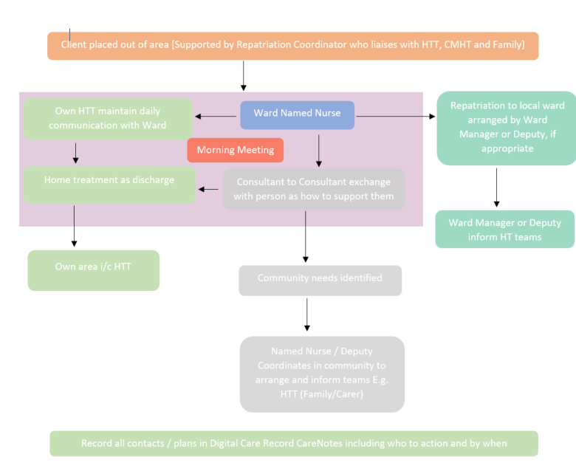

Appendix G – PICU Process & Providers

In the event of a person being assessed presenting with risks that might indicate a PICU admission is required then a referral to Junipers will be made by assessing team. Junipers will triage the referral and if not accepted will relay supporting guidance on how to manage patient in an acute setting. If accepted and beds available Junipers will liaise with assessing team, HTT and Bed Capacity of pending admission. It has been agreed that where possible the client should be managed within the acute ward utilising the Extra Care Area and additional necessary staffing to avoid PICU admission where possible. If no beds available at Junipers then they will review current patient list and see who is able to stepdown to an acute setting to create an admission bed. If this is not possible bed capacity to escalate to Directors for an OOA bed. HTT to coordinate who completes referral. Individuals and staff safety should not be compromised in this process and it may be necessary for the Ward Manager, Senior Nurse Manager or Service Manager to assist with discussions in office hours and the NNP or on call out of hours.

Below is an agreed list of PICU beds that should be considered in the order listed:

Table 1.PICU Hospitals
Cygnet Hospitals – 0808 164 4450 For referrals use Cygnet referral Line between 08:00 and 20:00 outside of these hours you will need to contact Cygnet wards individually availability of beds is available on line– Cygnet have a referral form and require copies of Risk Assessment, Progress Notes, Care Plans, Assessments, Medical Charts and MHAA paperwork. Details for all Cygnet Hospitals can be found On Cygnet Website
Priory Hospitals – Priory Hospitals – Central Referral Line (24 Hours) – 08450005050 – Priory will take telephone referral in first instance and direct referral to most appropriate priory bed, then will need copies of Risk Assessment, Progress Notes, Care Plans, Assessments, Medical Charts and MHAA paperwork. Details for all Priory Hospitals can be found On Priory Website
Elysium Healthcare – Referral Line 24 hours - 0800 218 2398 – Elysium have a referral form and require copies of Risk Assessment, Progress Notes, Care Plans, Assessments, Medical Charts and MHAA paperwork. Details for all Elysium Hospitals can be found On Elysium Website
St Andrews Healthcare – Referral Line – 01604 616000 – Direct telephone Referral to individual ward then referral form and require copies of Risk Assessment, Progress Notes, Care Plans, Assessments, Medical Charts and MHAA paperwork. Details for all St Andrews Hospitals can be found On St Andrews Website
The Huntercombe Group - (Female Only)– Direct Number 0330 660 5555 – Direct Telephone call then referral form and require copies of Risk Assessment, Progress Notes, Care Plans, Assessments, Medical Charts and MHAA paperwork
If the bed is required as a result of a MHA assessment then it may not be practicable for the AMHP to be involved in facilitating requests for funding agreements and any written information other than the detention papers and AMHP report. HTT teams and Night Nurse Practitioners must work with the AMHPs to ensure the required information is available to the provider. In the case of a MHA assessment the AMHP is responsible for organising appropriate transportation (See Appendix H)

Appendix H – Transport Providers In Order Of Preference

Transport to all areas for all ages

Name | Telephone | Description of Service
Kernow Ambulance (All Ages) | 07847 071780 | 24hr Service - HDU Provider
First Care Ambulance | 01392 438522 | 24hr Service - Transport service to be booked between hours 8am – 6pm
Premier Ambulances | 0800 044 3919 or 07956 885621 | Non-emergency transport service for mental health/vulnerable patients being transferred between hospitals or in the community.

Appendix I – Section 140 Admission to Trust wards

Q What does S140 mean?

A Section 140 is not a detaining section and as such there are no powers of conveyance, treatment or detention. In order to convey the person to the hospital an application must first be completed by the AMHP (e.g. s.2 or s.3 or informal admission) and will then be received by inpatient nursing staff in the usual way. If a bed is identified at a different hospital, following the ‘S140 admission’ of a person, a S19 transfer will be required in the usual manner.

Q What does the paperwork look like for S140?

A The paperwork will be the ordinary sections such as S2 or S3 - S140 describes the process of admission where there is no bed, it does not change what nurses should expect to receive when a person is admitted.

Q Can S140 be used if the person is admitted informally?

A The Mental Health Act states that S140 can be used for persons who are admitted informally although it is unlikely that this will happen.

Q What do nurses do if a person is admitted using S140?

A. The nursing staff receive the papers in the ordinary way and complete the H3. If the person is informal then they need to be admitted using the established procedure. As there is no bed for the person to be on the ward for any significant length of time nursing staff must ensure that someone is continuing to locate a bed. (Bed Manager, HTT, Night Nurse Practitioner)

Q How do nursing staff enter the person's admission on the Digital Care Record as there is no bed for the person to be admitted to?

A The person is admitted on Digital Care Record as a day attendee

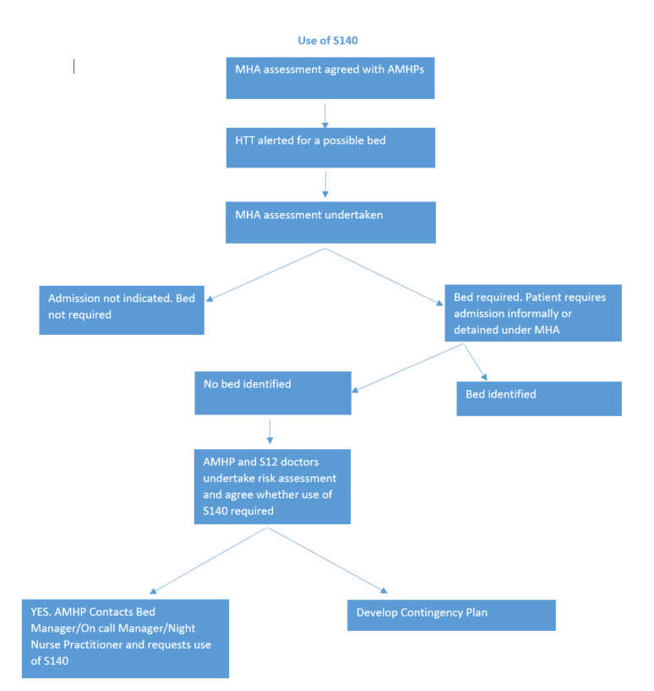

Appendix J – Inpatient Ward Bed Compliment

Inpatient Ward Bed Compliment – correct as date of policy

Ward – Specialist Services | MH Beds
Additional Support Unit | 5
Haldon Unit | 12
Russell Clinic | 10 + 6 Flats
Mother and Baby Unit | 8 (16 with babies)
Junipers | 10
Total Beds | 45
Ward – Older Persons Mental Health | MH Beds
Beech | 16
Belvedere | 14
Meadow View | 16
Rougemont | 16
Total Beds | 62
Ward – Adult Acute | MH Beds
Coombehaven | 16
Delderfield | 16
Haytor | 16
Sycamore Ward (Contracted) | 16
Glenbourne Contracted | 6
Moorland | 16
Total Beds | 86

Secure and specialist services beds are not admitted to via HTT except Junipers and Bed Capacity.

Extra Contracted beds Acute | MH BEDs
Cygnet Taunton Sycamore and Peacock | 9
Cygnet Kewstoke Sandford Female Acute | 15
Cygnet Woking Acorn Ward(Female PICU) | 1

Please note these numbers may change in exceptional circumstances i.e. Covid Pandemic. Please contact Bed Capacity or view Inpatient Dashboard for up to date figures.

Appendix K – Bed Capacity Flow Chart
Person Assessed as requiring admission to services- Psychiatric Liaison Team and AMPH’s contact Local HTT to Commence Gatekeeping Process

HTT review Local Delivery Unit Bed availability
Assessment of patient need and the available beds

Bed not available within
Local Delivery Unit
HTT refer the patient to the
Bed Capacity Team
Bed is available in the Local Delivery Unit
Patient admitted to the ward

Bed Capacity Team view the Trust wide bed availability
Bed Capacity Team determines the flow and capacity from all referring teams and the bed availability

No bed available within the Trust
- Bed request escalated to Locality Director during core hours.
- Bed request escalated to on Call Director
- Relevant Director gives authorisation for Private bed if appropriate
Bed available elsewhere in the Trust
Patient is referred to by HTT for the available bed and admitted

Bed Capacity Team locate Private Bed
- HTT informed of Bed and arrange referral
- If referral is not appropriate then the bed request goes back to Bed Capacity to locate another bed.
Bed available with
Private Provider
Person admitted into
private bed

Patient referred back to Bed Capacity
- Bed Capacity Team reviews the options for increasing bed numbers within Trust inpatient wards.
- Local wards contacted to assess the following criteria::
- Ward Acuity.
- Safer Staffing levels.
- Place of Safety availability.
- Senior Nurse Manager contacted to discuss the available options in office hours.
- On Call manager contacted during On Call period.
- Night Nurse Practitioner contacted during night period.
- Increase to bed numbers agreed
- Individual admitted to the receiving inpatient ward.
- Senior Nurse Manager contacted to confirm admission during hours.
- Night Nurse Practitioner contacted to confirm admission during out of hours
- Bed Capacity escalate increase in bed numbers to the Director of Nursing (DoN) 01392 208683 complete RMS
- CCG/CQC contacted during office hours to notify the increase in bed numbers by the Director of Nursing.
- Ward now above contracted bed numbers.
- Extra Staffing sourced to ensure safe ward
- Co staffing numbers are correct.

Appendix L – Bed Protocol – use of non-designated bed rooms procedure

Bed Protocol – use of non-designated bed rooms procedure

When Trust beds are not available either due to there being no vacancies or leave beds to admit to the following process has to be followed. Admission or holding within 140 to Place of Safety (POS) would be considered in an emergency with agreement from the Senior Nurse Manager in hours or via Director on call. This may include an extra provision of staff to allow safe nursing of the person accessing the service away from the ward environment.

Non designated Bedroom’s i.e. female lounges should not be considered as temporary bedrooms due to a series of risk factors including ligature, breaches of individual’s privacy and dignity, manual handling for staff members and the general safety of the ward. Rooms specified for use as patient bedrooms have under gone a thorough risk assessment to determine a safe environment for patients to access. When using rooms not designed as sleeping accommodation the basic human rights of patients regarding privacy and dignity are breached. By creating an extra bed room within an inappropriate area there is serious risk of manual handling injuries due to the transfer of spare beds from storage to the new location, putting staff in positions of potential harm. Use of patient specific areas including lounges diminishes the care experience for other persons on the ward as they are denied access to pre-designated communal areas.

If a bed is still required then the escalation process through the respective manager/ Director needs to be followed with other solutions determined to meet the needs of the individual. This may include requests for out of area beds or access to specialist placements as determined by the care pathway needs of the patient.

Ward Bed Numbers

Each ward has an agreed bed number which may fluctuate when on leave beds are used – see Appendix J

It is not acceptable to increase bed numbers and have more than the designated number of people sleeping on wards when we have capacity issues unless there has been an agreed plan and process signed off by an Executive Director (See bed capacity Flow Chart – Appendix K). This decision would need to be in the best interests of the person in receipt of our services at that time. It is important to ensure that a comprehensive clinical risk assessment of the individuals presenting physical and mental health state has been undertaken. An RMS incident form will also be completed. The appropriate support and infrastructure is available to meet the individual needs. We would also ensure that the Care Quality Commission (CQC) and the Clinical Commissioning Group (CCG) (North, East & West or Torbay) are informed when we do this by exception only.

Appendix M – Process For When A Person Is Admitted To Police Custody
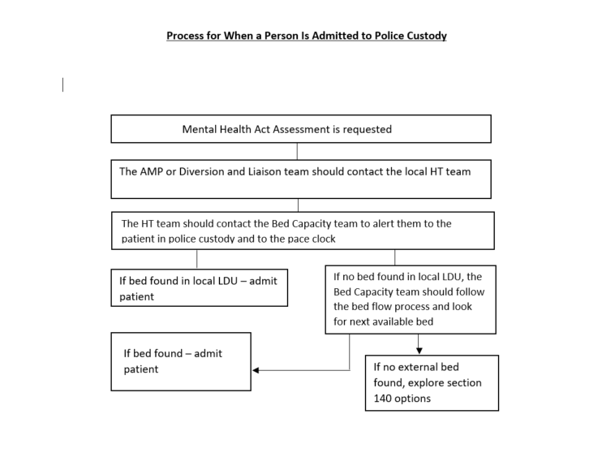

Appendix N – On Call Director – Requests for Private Beds
On Call Director – Requests for Private Beds (outside DPT contracted beds)
Patient Name: |  | Date:
Patient’s Location: ☐Community ☐DPT Ward ☐ Local General Hospital Ward ☐Local A&E
☐Custody ☐ Other MH Hospital ☐ Other General Hospital
☐ Other (please state)
Bed Type Requested: ☐Adult ☐OPMH Functional ☐OPMH Organic ☐PICU
For Adult, OPMH Functional and OPMH Organic:
Have CRHT(s) reviewed all current inpatients to see if leave can be granted/ extended or if early discharge can be facilitated? |  | ☐Yes ☐ No ☐ N/A
Has the request been screened by the on call consultant? |  | ☐Yes ☐ No ☐ N/A
Has the referrer explored the use of: | Step-down/Crisis beds?  Family/Carer Support?  Temporary Staffing? (either through DPT or Social Care as appropriate) | ☐Yes ☐ No ☐ N/A  ☐Yes ☐ No ☐ N/A  ☐Yes ☐ No ☐ N/A
Have Bed Capacity exhausted any and all options of using available DPT beds in other LDUs/bed types. |  | ☐Yes ☐ No ☐ N/A
If the patient is in Police Custody, can they be transferred to a DPT POS Suite as an interim solution? |  | ☐Yes ☐ No ☐ N/A
If the patient is in the general hospital, have they been reviewed by HTT to explore home treatment/step-down? |  | ☐Yes ☐ No ☐ N/A
If the patient is in the general hospital, can the patient remain there if additional staffing is funded/provided by DPT? |  | ☐Yes ☐ No ☐ N/A
If the patient is currently outside DPT, can they be admitted to an NHS bed in that area? |  | ☐Yes ☐ No ☐ N/A
Have nearby NHS Trusts been approached (e.g., Plymouth, Somerset etc.)? |  | ☐Yes ☐ No ☐ N/A
Can the patient be safely admitted to an extra bed on a DPT ward over that ward’s usual numbers? |  | ☐Yes ☐ No ☐ N/A
For PICU:
Have the ward followed the PICU policy and protocols? |  |  | ☐Yes ☐ No ☐ N/A
Has the request been screened by the on call consultant? |  |  | ☐Yes ☐ No ☐ N/A
Are there any DPT patients ready to return from our contracted PICU beds? |  |  | ☐Yes ☐ No ☐ N/A
Authorising On-Call Director:

Return Completed form to dpn-tr.bedcapacity@nhs.net

Appendix O – Child Adolescent Mental Health Service Out of Hours Guidance

For DPT Managers and Clinicians in and out of Hours

The following is guidance aimed at clarifying the current arrangements for admitting Younger Adults under the age of 18 years olds to Adult Inpatient mental health )Wards.
- The identification of an appropriate CAMHs beds remains the responsibility of the CAMHS team with NHS England (-CCG don’t co-ordinate OOH, as per NHS England 136/Tier 4 bed flow charts) refer to Appendix A. HTT are not responsible for finding an appropriate bed. Senior Manager on call are responsible for coordinating the communication with the Clinical commissioning group and ensuring adequate escalation is in place.

- Any request for the Place of Safety (POS) to be opened for an under 18 year old needs to be escalated via Director on call and Consultant on call. Status informal or detained to be established and/or Mental Health Act assessment/requirement. Check Status of any Transition i.e. 17 years old to adult services and gain relevant information.

- If there is potential to admit someone under 18 because there is no Child Adolescent Mental Health Service (CAMHS) Bed immediately available and it deemed to be a clinical emergency, there needs to be a telephone conference call between on call Senior Manager and/or Director Site nurses/Night Nurse Practitioners (NNPs) and the on call Consultant (RC) to determine which would be safest ward to admit to in line with the Bed Management Policy. The admission will be for the shortest time possible pending rapid transport to a dedicated CAMHS unit.

- Whilst on an Adult Inpatient Ward the medical care responsibility is with the adult inpatient RC or if out of hours then the on call RC.

- Bank or Agency nurses must be identified with CAMHS experience to provide 1-1 nursing care at all times, with a minimum of 2 staff identified. This will ensure the prevention of compromise of care to others using the service. A separate area (Segregation) must be provided for anyone under 18 – where possible avoid the use of Extra Care Area (ECA). If ECA is required then this will need 2:1 nursing. All additional staff will be funded by CAMHS following funding approval from NHS England.

- The CAMHs Team must be invited and attend a review of the person a minimum of once per day. . Age appropriate care plans to be formulated with input from CAMHs and agreed by all concerned.

- The CAMHS team will be responsible for urgently liaising with external agencies to ensure an appropriate, rapid and safe discharge to a dedicated CAMHS unit. This will be prior to and throughout the admission until transfer is completed.

- An RMS data incident form and a safeguarding alert must be completed by the ward staff.

- Director on call will ensure that the CQC/NHS England and CCG are informed.

- Any person under 18 years old must be admitted onto care notes record system following the same process as is used for any new admission and staff will continue to work within DPT policies, protocols and the legal framework.

- Nursing staff must ensure the involvement of the person’s family and carers.

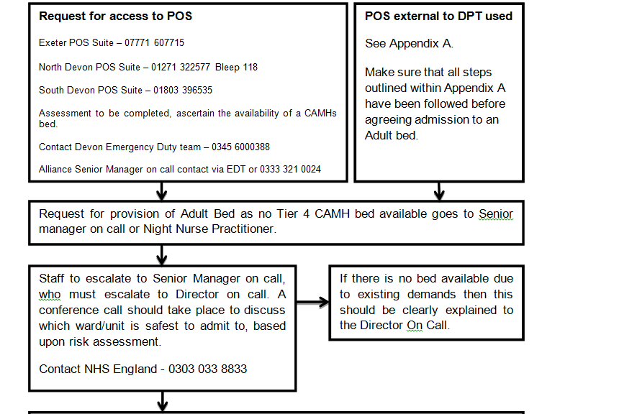
Centralised POS Suite – 07771 607715
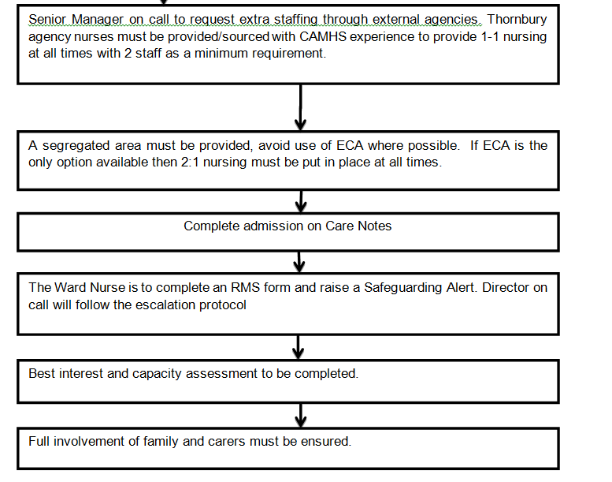

Escalation process in Devon and Torbay for a child in mental health crisis requiring assessment or detained under section 136

If the Police identify that a young person is in mental health crisis and detained under s136 they should immediately contact CAMHS Place of Safety Suite at Plymbridge House Plymouth 01752 435434) (see flow chart Annex A).
The child should be conveyed straight to the children and young people’s [Plymbridge House] place of safety and not be taken into Police custody unless arrested for a substantive criminal offence.
The local CAMHS provider and Local Authority AMHP informed and should undertake an initial assessment within four hours of arrival at the Place of safety suite.
If no child and adolescent POS is available the police are require to take the child to the nearest hospital A&E department. If not able to do this consideration to admission to an adult POS should be considered.

This shouldn’t be included as detention at custody for under 18 is a never event Where an individual is removed to a police station as a POS, the reason they cannot be accommodated at the health POS should be recorded on the custody record, MHA monitoring form and referred to the local operational group. The Custody Sergeant will also complete a ‘Police Mental Health Detention Report’. This will allow review and focus on the number of times each custody centre is used. Where an assessment and care plan cannot be put in place within 1 hour the Police Custody Officer/sergeant should escalate to their respective Clinical Commissioning Group (CCG) on call director or local CAMHS provider should use flow chart at annex B.

Devon CCG Director on Call – In hours – 01392 356050
Out of Hours – 01392 269460
Ask for CCG On-Call Director to be telephoned

The CCG on call director should convene a Telephone Conference with the following providers to find a suitable placement and appoint a professional lead. The following should be included as a minimum:

CCG to chair and provide secretariat function and provide teleconference details
Devon Partnership NHS Trust - In hours – 01392 208866 - out of hours - 01392 411611
Contact Devon Emergency Duty team – 0345 6000388
Plymouth Community Healthcare – 01752 268011
NHS England BNSSSG Area Team Specialised Commissioning Team – 0303 033 8833
Holding Organisation (Health) as appropriate
Police via the Force Incident Manager 01392 223486- In of hours (0700-2359Hrs) ask for the Core Custody Inspector
Front line clinical team as appropriate
Local Authority as appropriate
Alliance Senior Manager

If a suitable placement cannot be found within 4 hours, then a further Executive level call should be arranged to include:

All of the above organisations Executives on call plus
DPT executive on call – In hours – 01392 208866 - out of hours - 01392 411611
and/or
CPFT executive on call – In & out of hours – 01208 251300
Private Sector providers identified by NHS England Specialised Commissioning Team

If placement can still not be provided then it should be reported as a NEVER EVENT.

Appendix P – MBU Admission Pathway

Jasmine Lodge MBU is a regional specialist unit commissioned directly from NHS England. Bed referrals are made directly to the unit and will then (within working hours) be discussed with the MDT including the consultant and ward manager.

The MBU is commissioned to accept women 24 hours a day 7 days a week so referrals can be made at any time. If someone is referred outside working hours then the nurse in charge of the shift will triage the referral. It is possible that the nurse may wish to speak with the on call managers or consultant if they would like further advice. This is more likely if the nurse in charge decides that a bed isn’t appropriate or that there are no beds available. This would mean that an alternative plan would have to be agreed with the referrer; in this case, the nurse in charge will give relevant information to the referrer, for example, give the referrer numbers for additional MBU’s or advise that an acute bed is found.

Who does the service provide care for?
Admission criteria
Postpartum Psychosis or previous history of

Diagnosis of Bipolar Affective Disorder, Schizo-affective disorder or other psychoses

Moderate or severe antenatal/postnatal depression or anxiety disorders including previous severe depressive episode/post natal depression-requiring treatment in hospital/secondary care.

Mothers with these conditions under the age of 18 are accepted if there is a significant perinatal mental illness and they are likely to be the infant’s principal carer. Inpatient Mother and Baby Units are suitable for the admission of a young mother aged 16-18 but the admission will be managed in collaboration with Child and Adolescent Mental Health Services (CAMHS) and Social Services.

Women in the antenatal period over 32 weeks gestation

Exclusion criteria
For sole purpose of a parenting assessment

Women with severe personality disorder, learning disability or substance misuse unless they are also suffering from, or there is suspected, serious mental illness

If there is evidence that the mother will not be capable of independent functioning in caring for her infant in the community with reasonable support

If there is evidence of serious violence/aggressive behaviour that might pose a risk of harm or injury to her own or other babies on MBU.

Babies/ Infants on the ward

- Babies will be registered temporarily if needed at Wonford Green GP Surgery and during working hours will be booked a GP appointment if there are concerns about their physical health. If there are concerns outside GP working hours then Devon Doctors (GP out of hour’s service) should be contacted. They will refer for paediatric assessment if they feel this is required. This is the protocol agreed with consultant paediatrician colleagues.

- If this cannot be accommodated then the paediatric SpR on-call can be contacted for advice or the baby could be taken to A&E. However this should only be considered if the other options have been explored.

- Junior doctors on call may be asked to come and assess babies’ physical health. There should be a very low threshold for requesting additional medical advice through Devon Doctors and Wonford Green GP Surgery.
- In the event of an infant appearing acutely unwell or there are concerns that this might be the case then an ambulance should be called. All substantive MBU staff should be trained in infant BLS.

- If an infant requires transfer to a hospital this will ideally be done with their mother or other parent. However should the infant require medical attention either by a G.P. or at the Children’s Hospital and a parent is unable to attend, MBIS staff will ensure that the baby is taken there promptly (s3.5 Children Act 1989).

- Where doubts exist regarding a mother’s capacity to validly consent at the time a decision needs to be made, then actions to safeguard the health and well-being of the baby will be taken in accordance with s3.5 Children Act 1989 and s4B Mental Capacity Act 2005.

Appendix Q - 12 hour trolley breaches Acute Trusts / DPT

Standard Operating Procedure (SOP)

“The waiting time for an emergency admission via A&E is measured from the time when the decision is made to admit, or when treatment in A&E is completed (whichever is later) to the time when the patient is admitted.

Time of decision to admit is defined as the time when a clinician records a decision to admit the patient or the time when treatment that must be carried out in A&E before admission is complete – whichever is the later.” (NHS England, Daily SitRep guidance, 2013-14)

The decision to admit (DTA) to a mental health care bed will be made by the Liaison Psychiatry clinician (B6 and above) in conjunction with Crisis Resolution & Home Treatment Team (HTT).

HTT make this gate keeping decision NOT Liaison. As HTT can go and see someone that Liaison thinks need an admission and they can more often than not turn that person around to Home Treat. Stating the above Kay will be interpreted as Liaison Gate keeping and not HTT. Can you remove that part?

When admission to an acute mental health care bed is required from an A&E department, the transfer should occur within 4 hours of the DTA. Exceptions will be based on clinical need, capacity to home treat and location of pending available beds should always be considered and prioritised, and ensuring people get the support they need as close to home, and their family and friends, as possible.

If any medical treatment is required in A&E this must be completed and the patient deemed medically fit for transfer to an acute mental health bed before a formal DTA can be made.

Liaison Psychiatry will ensure all 12 hour breaches are captured and reported up to the Executive Board

- FORMAL / INFORMAL ADMISSIONS

  - If an informal admission is required the DTA is when the Liaison Psychiatry practitioner (B6 and above) has agreed this is required in conjunction with HTT as the gatekeepers and the patient has consented to the admission. – NEEDS REPHRASING AS LIAISON DO NOT GATEKEEP – HTT DECISION

1.2 If a Mental Health Act Assessment (MHAA) is required in order to facilitate an acute admission, the DTA remains as the time when the original decision was made. Any delays in accessing a MHAA would therefore be included in the 12 hour period.

  - If someone has remained a long time informally waiting a bed and a MHAA subsequently occurs, the decision to admit remains the time the informal decision was made (see 1.1)

  - If someone is subsequently discharged home from the A&E, this is no longer deemed a 12 hour breach.

Whilst waiting for an available bed, the Liaison Psychiatry team will ensure that the patient concerned, their carers and the Acute staff are updated regularly.

A care / management plan will be put in place and regular review and monitoring of this will occur whilst they remain in the A&E. Psychiatric consultant review will occur as required, but as a minimum this should occur within 24 hours of the DTA if they remain in the department.

- DOCUMENTATION

  - The DTA time will be clearly documented, using the 24 hr. clock in the following places;
A&E notes
Care Notes (progress note)
On relevant Liaison Psychiatry whiteboard
On relevant night report
Bed Capacity report

- ESCALATION – see below

3.1 Communication / documentation regarding escalation – see below

Devon Partnership NHS Trust (DPT) 12-hour Breach Reporting Protocol

2 hours after the decision to admit

- Acute Trust and Liaison Psychiatry to talk through the position and, if known, the expected departure time of the patient.
- Internal escalation through DPT should also be ongoing until the patient is safely discharged.

6 hours after the decision to admit

- Liaison Psychiatry to escalate to relevant Managing Partner or deputy in hours - senior manager on-call / NNP out of hours.

8 hours after the decision to admit

- Deputy Chief Operating Officer / On-Call Director to be informed.
- If no solution is in place then the Acute Trust will notify the CCG to agree a plan at this point.

At 10 hours

- DPT Director or deputy / On-Call Director should provide the RD&E Director or deputy / On-Call Director and CCG (Lead Commissioner for Urgent Care - 01392 26762 / CCG On-Call Director - 01392 674808) with a progress update.

At 12 hours & ongoing until resolved

- DPT Director or deputy / On-Call Director, Acute Trust Director or deputy / On-Call Director and CCG On-Call Director to remain in agreed regular contact until the situation is resolved.

Within 24 hours of breach or next working day

- Acute Trust submits initial report to the Lead Commissioner for Urgent Care who, without any delay, submits to NHSE Local/Region and NHSI.

Key phone numbers:

DPT Bed Capacity team | 01392 208698
DPT Psychiatric Liaison Teams | RD&E 07807 787691 (24/7)  NDDH 01271 443244  (Night Nurse Practitioner 01271 443208)  T&SD 07801 227243 (24/7)
Acute Trust Switchboards ( to access on-call managers for Acute Trusts and DPT) | RD&E 01392 411611  NDDH 01271 322577  T&SD 0300 456 8000
CCG Director On-Call | 01392 674808
CCG Lead Commissioner for Urgent Care | 01392 26762

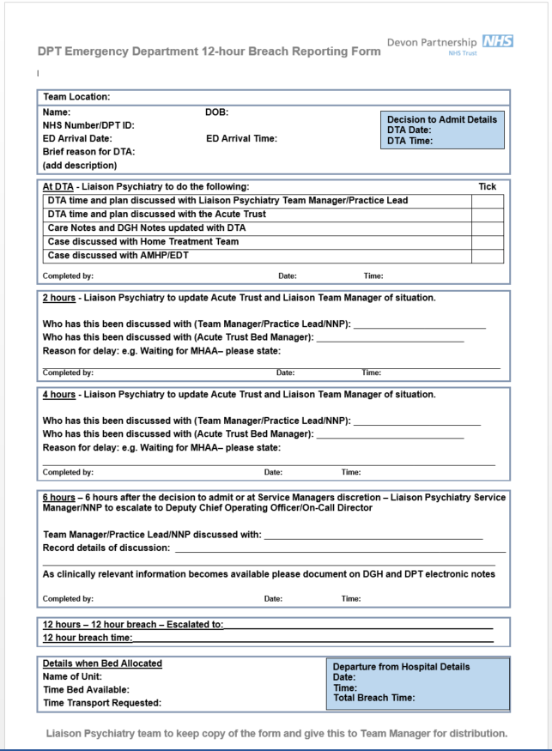

Appendix R – OMPH HTT External Referrals
